

**GLOBAL CODE SUMMER CAMP 2019**

GROUP EAGLES

EAGLES’ QUIZ APP

DOCUMENTATION

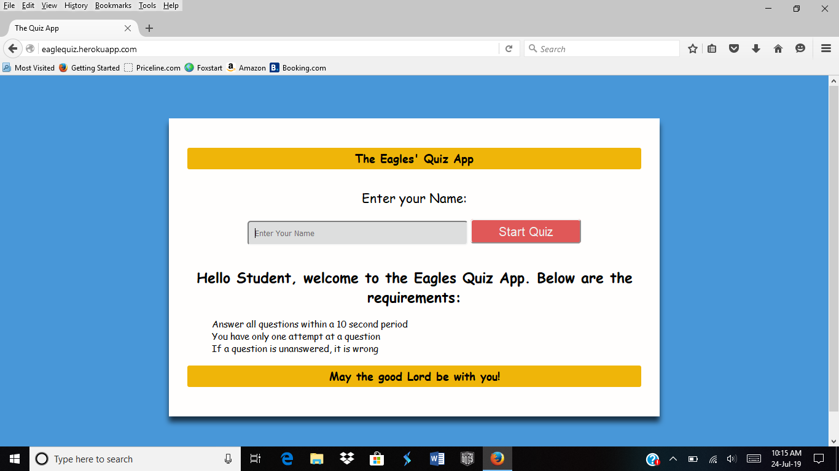

This is the start page of the quiz app, ***The Eagles’ Quiz App***. It requires a user to enter his name and then read the requirements for the quiz. The **start quiz** button will take the user to the next page when it’s clicked on.

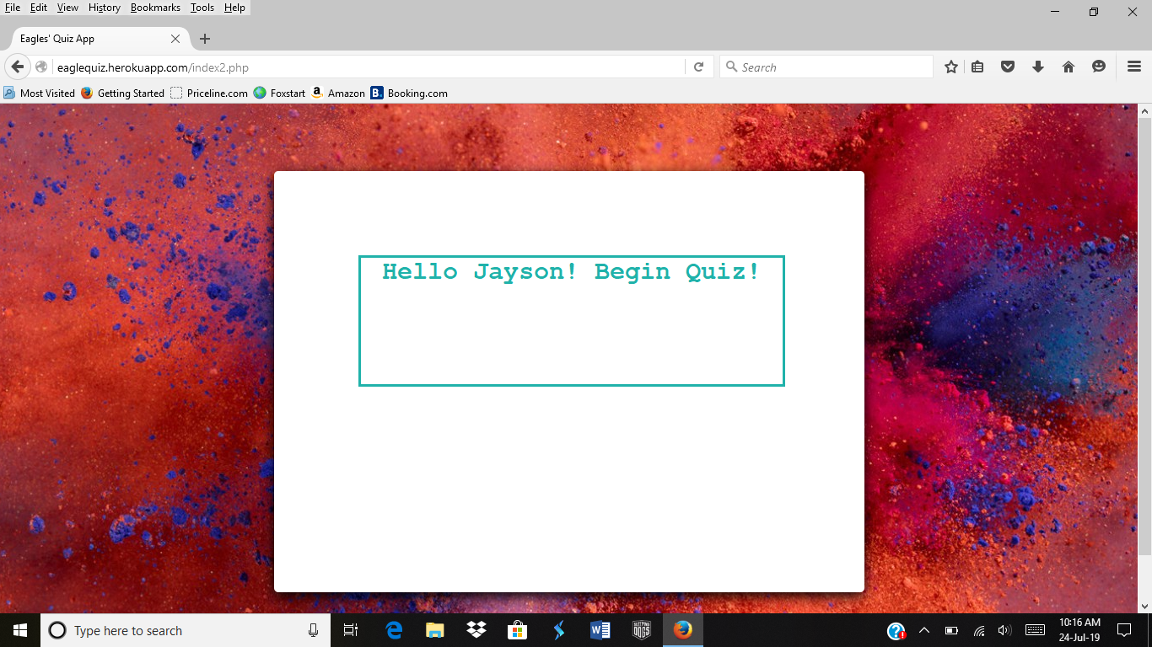

This is what we call the welcome page. This is to alert the user of his request to start quiz. It is a link that takes the user to the start of the quiz when it is clicked on.

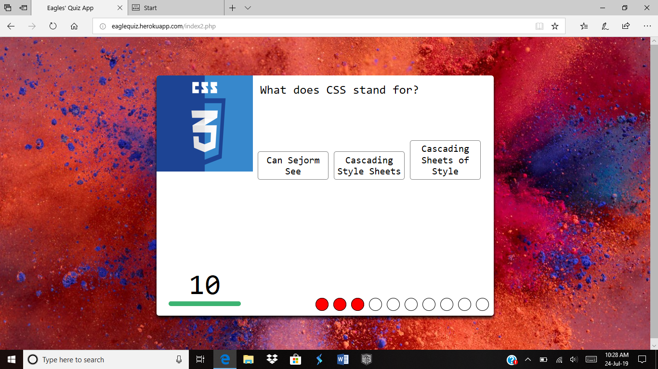

This is the start of quiz. When a user selects a right answer, the empty circle is filled green else it is filled with the red fill. User has just ten (10) seconds and an attempt to a question.

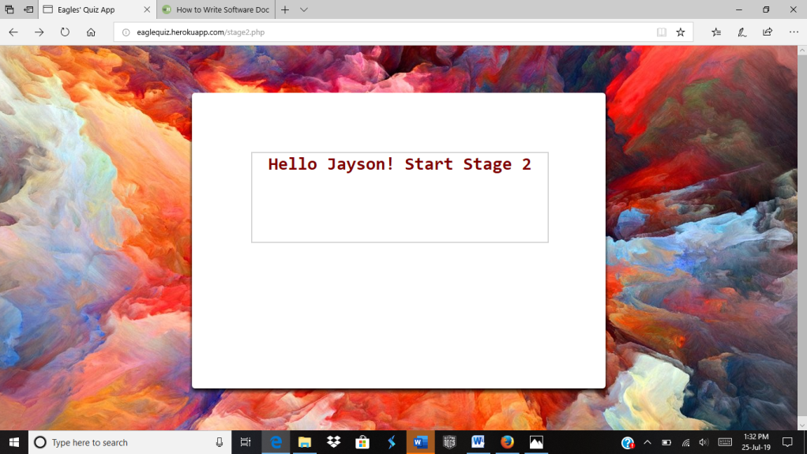

The quiz comes in two stages, the first stage and the advanced stage. The user gets to start another set of questions; even more difficult questions ***if*** user scores 50% and above. Just like the first, this welcome message is a link that takes the user to the next set of questions.

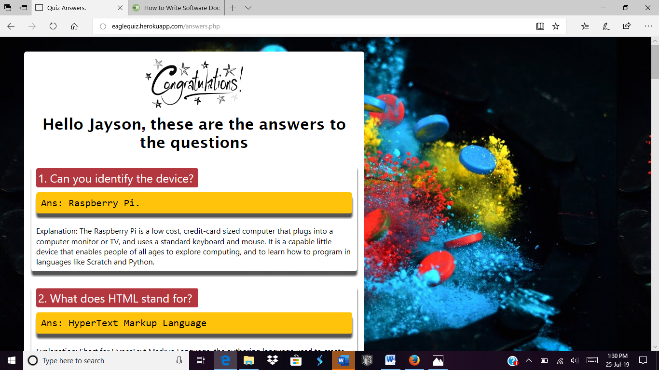

This is the last page of the Eagles’ Quiz App. Taking into consideration how to advance the knowledge base of the user; we provided a page with all answers to the quiz. This page does not only give answers but also a detailed explanation to the answers hence, widening the knowledge horizon of the user.

**PROJECT ABOUT**

This project was built for everybody. It is an app to test the knowledge base of its users on general computing and the fast growing technology. Our inspiration came from our change of project which was to build a motion detecting system, we thought, why don’t we create something that will help students and everyone at large? We realized there were a lot of things we knew but didn’t know how and when they came about. Thus, we took advantage of this opportunity to help ourselves and other students at large and anyone at all that has a bit of taste for technology.

We believe this project will influence technology addicts to do more of research to knowing more about the “whys” and “how’s” behind technology. With the timing system added to the quiz app, students will also become conscious of working within a time range. Besides, technology itself has a spice of speed and not just the flavor of accuracy.

**WHAT DESIGN WAS USED?**

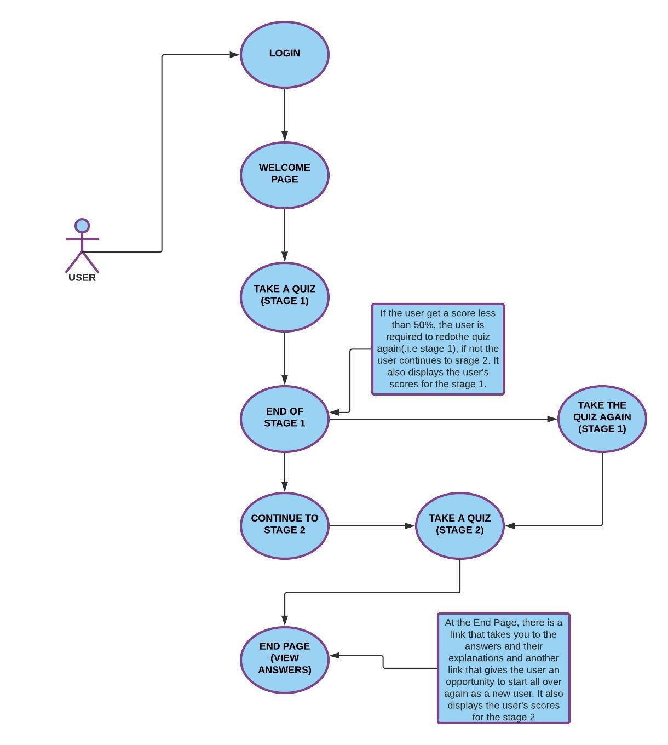

START PAGE

LOGIN PAGE

QUESTIONS BEGIN

CLICK ON LINK

WELCOME PAGE

ENTER YOUR NAME

SELECT ANSWERS

YES

NO

SCORE > 50%

SELECT ANSWERS

QUESTIONS

NEXT STAGE

REDO QUIZ

END OF PAGE

VIEW SCORES

TOTAL SCORE

WHAT TECHNOLOGIES WERE USED?

We used HTML and CSS to display the contents of the webpage. We stored the user’s name in a session variable with PHP. The questions are displayed with JavaScript and we also used JS to validate the answers the user chooses.